CUBS & BULBULS

Cubs and bulbuls is the first lap in the journey towards scouting and guiding . Character building is its aim. Instilling self – discipline and thoughtfulness for others, at a tender age, is the major focus, of the activities designed for this group. It prepares the boys and girls to take up bigger tasks in scouting and guiding and also helps in their mental and physical growth. Children learn to be independent and to live life in a disciplined manner. Students of std III – V can join this movement.

Syllabus of Praveshika
Cub/Bulbul Section
1. Be told the first Jungle story (for Cubs). Be told the story of Tara (for Bulbuls)
2. Understand the meaning of Cub/Bulbul Law, Promise, Motto, Prayer and Bulbuls six-songs.
3. Demonstrate correctly smiling, cub/bulbul salute and left handshake.
4. Do a daily Good-turn at home.
5. Grand Howl (for Cubs), Grand Salute (for Bulbul)
6. Whistle and Hand Signals.
From our Vidyalaya total 20 students ( 10 Cubs and 10 Bulbuls ) participated in Chaturth Charan and Heerak Pankh Examination .

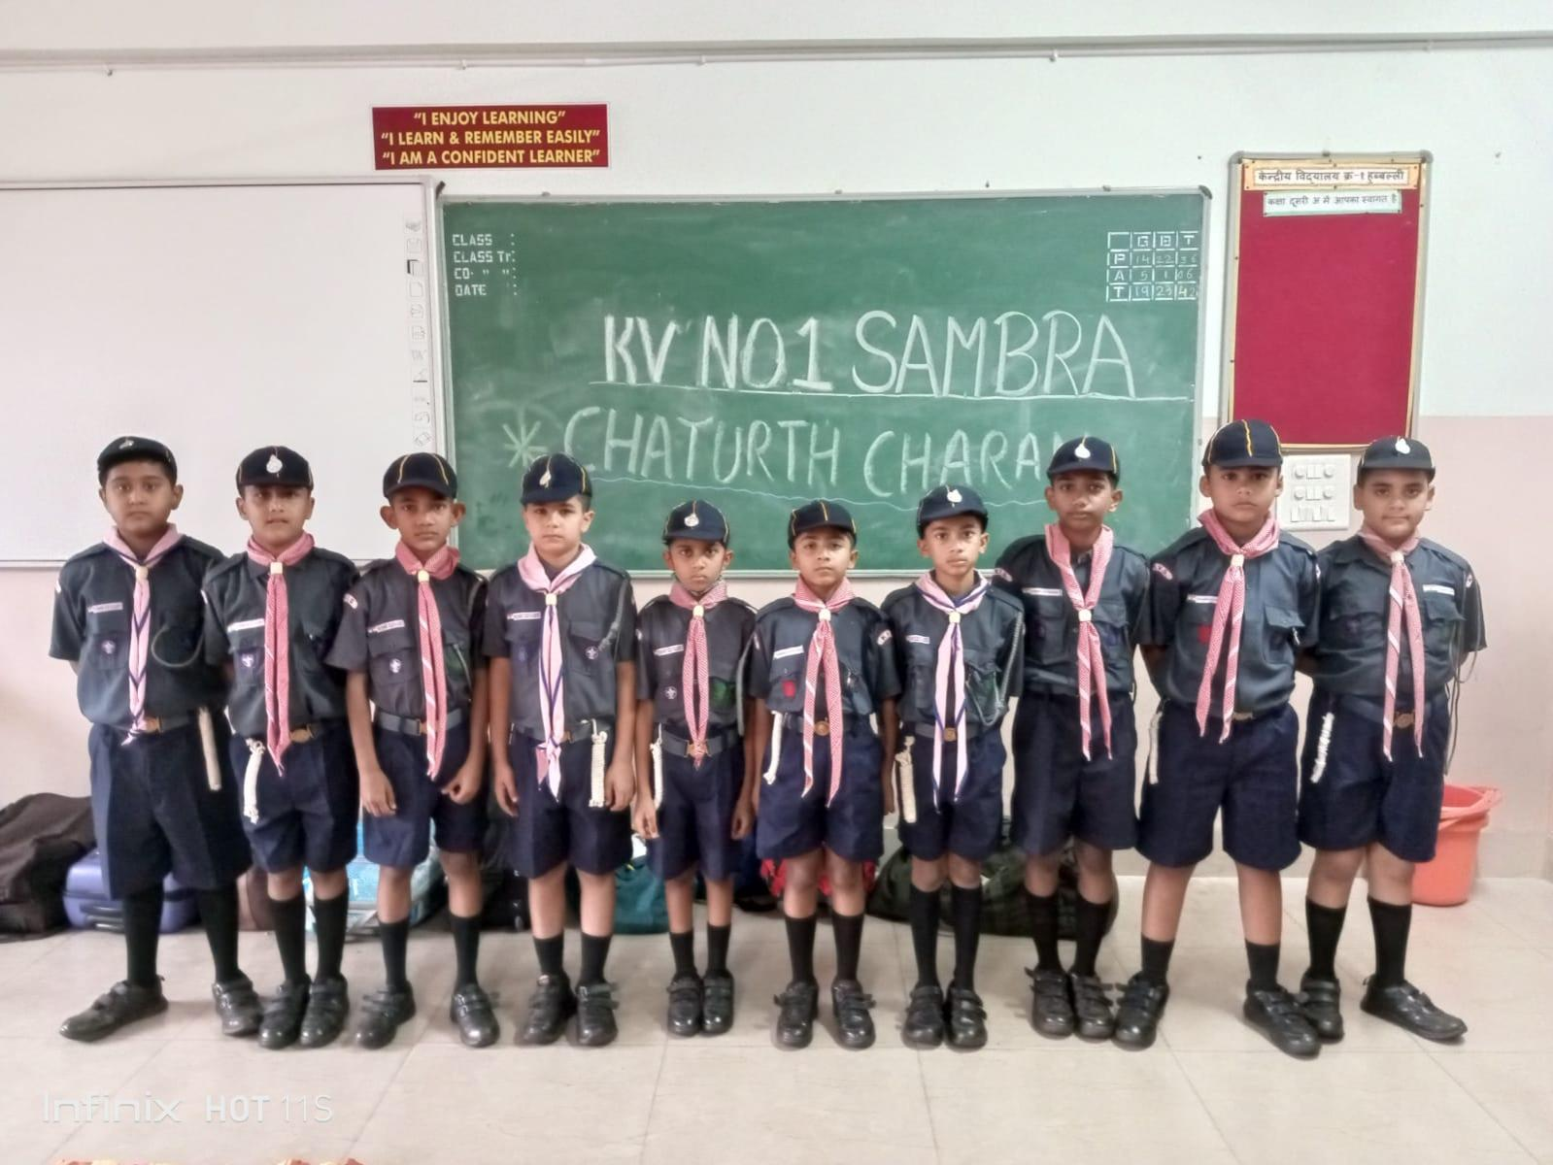

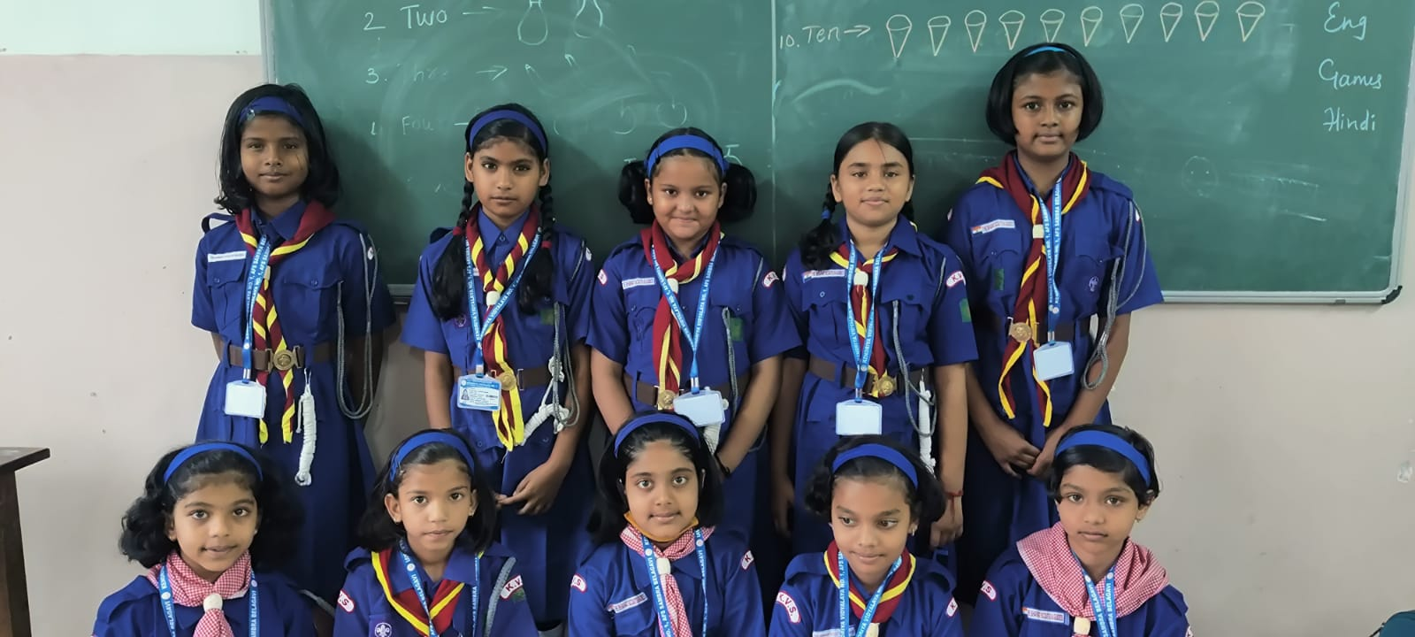

Departure of cubs and Bulbuls for Camp

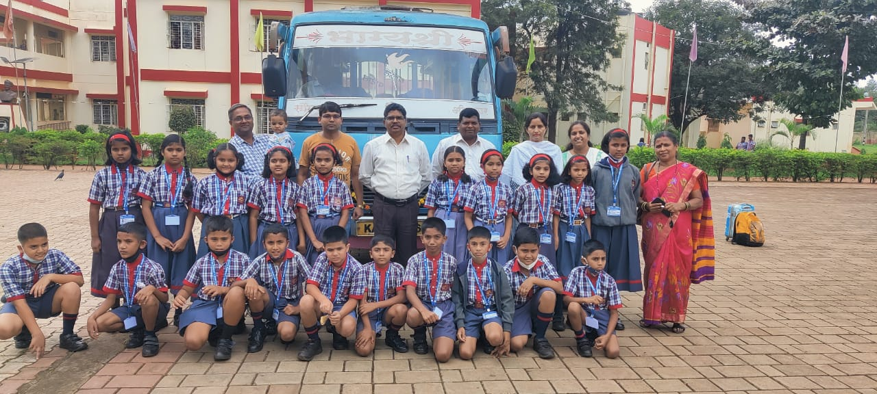

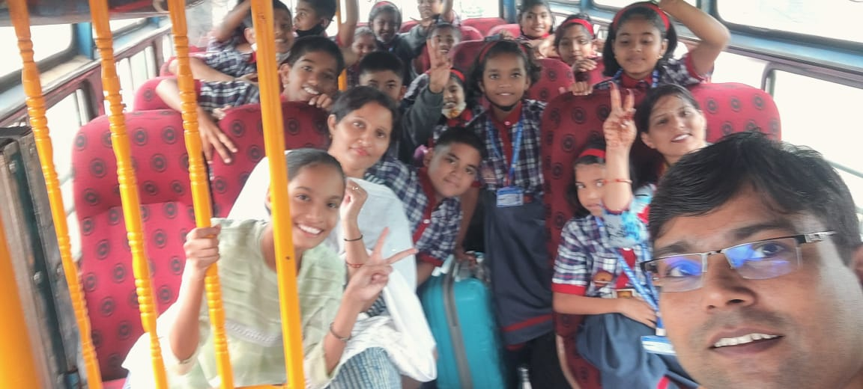

It is very important to understand that a student should not only be academically excellent, but there should be overall development too. And under the camp, students learn while doing fun. All the students along with escort teachers were very excited to being the journey.

Exercise Time

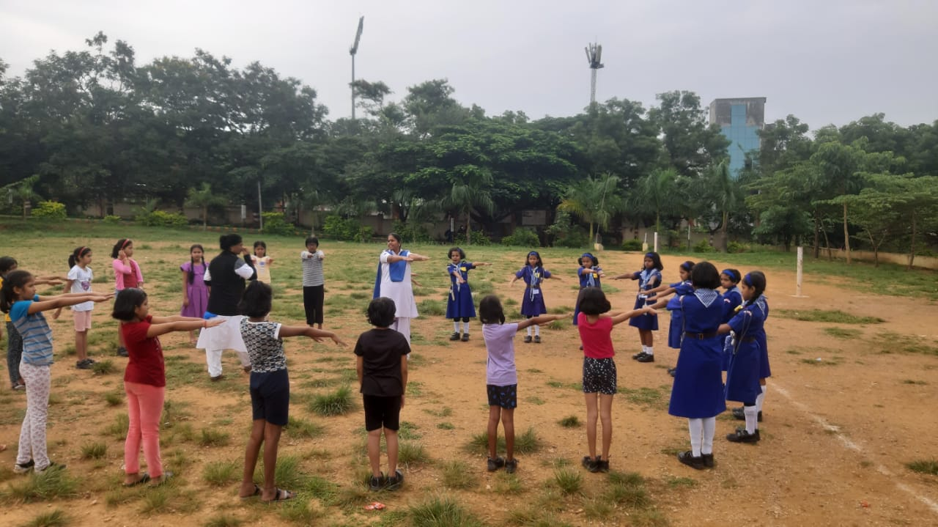

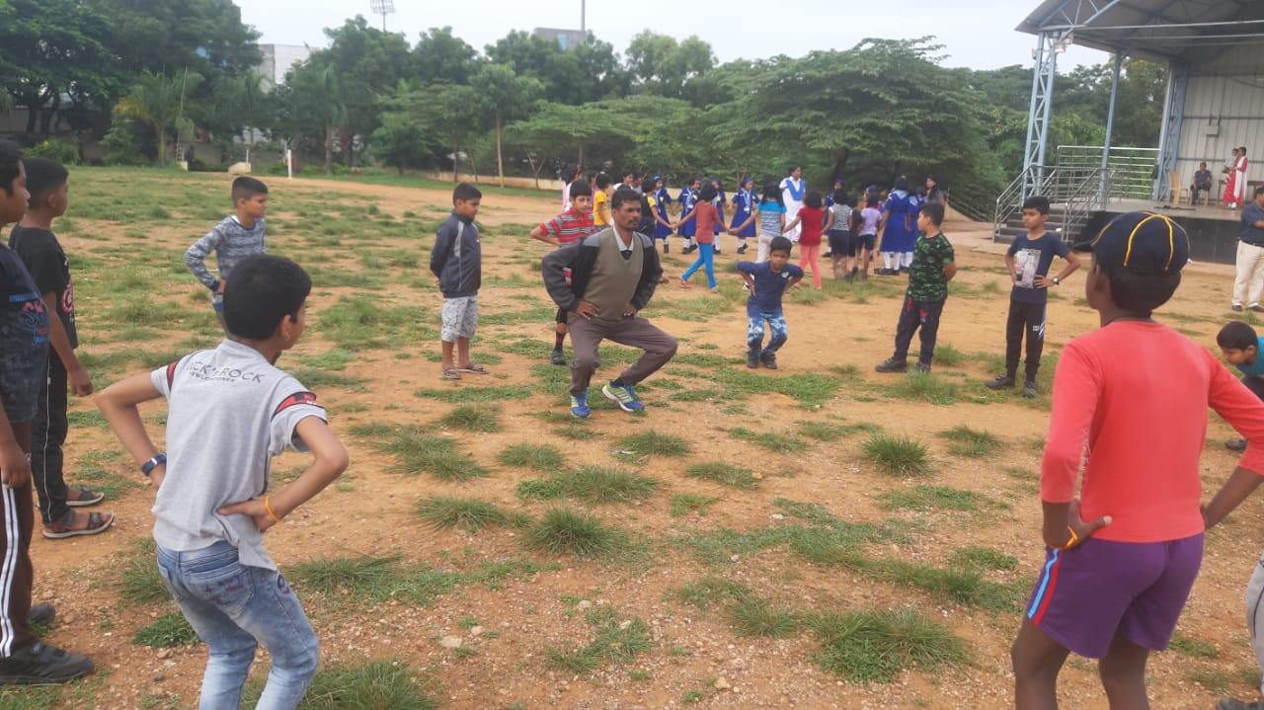

In camp various sports activities are held. Students are asked to wear proper uniform. A knot is also tied around their neck and the students are then asked to do a good deed daily and only open once they do something good.

Community Lunch

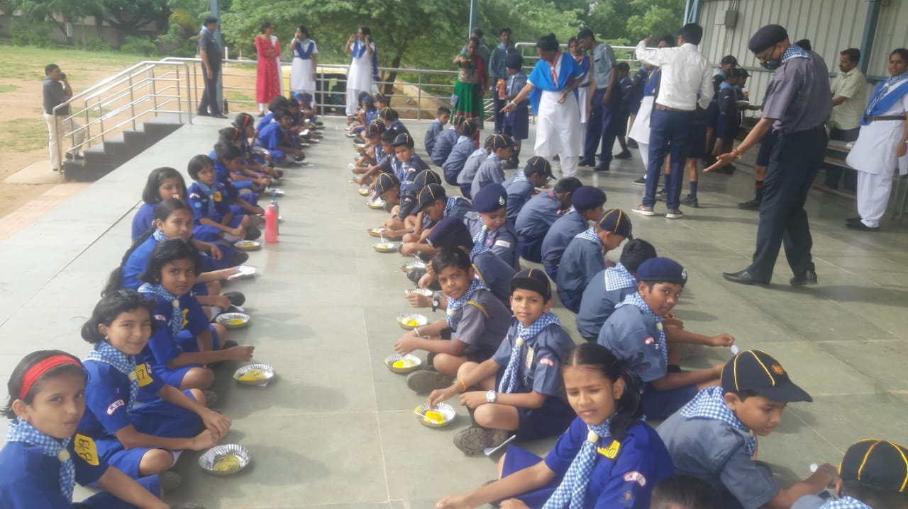

Prayer Time

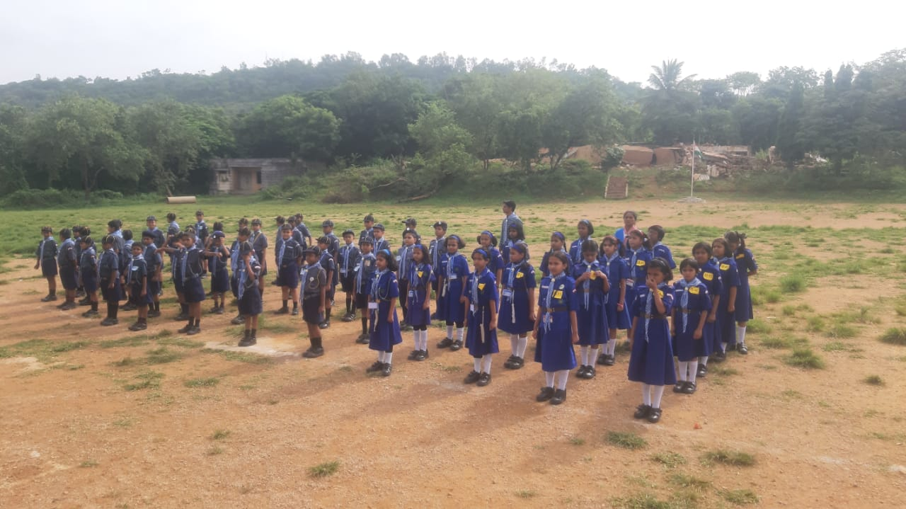

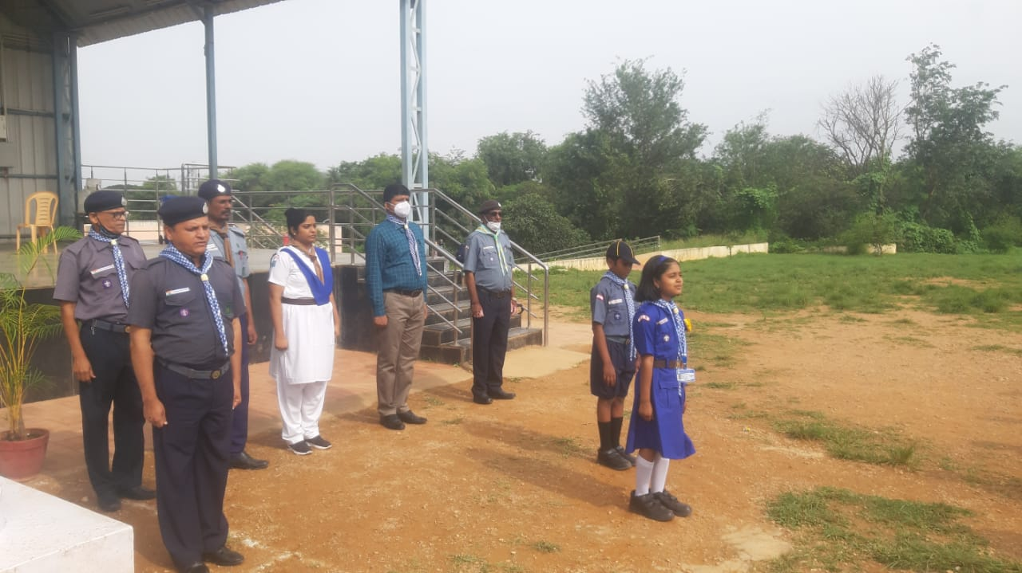

Closing ceremony

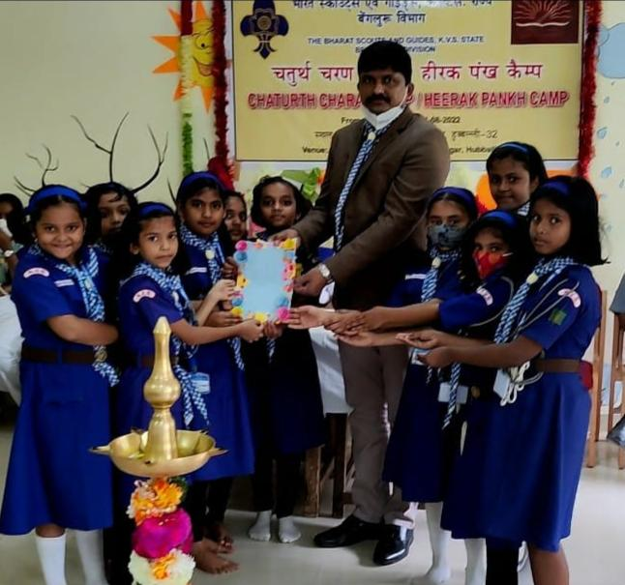

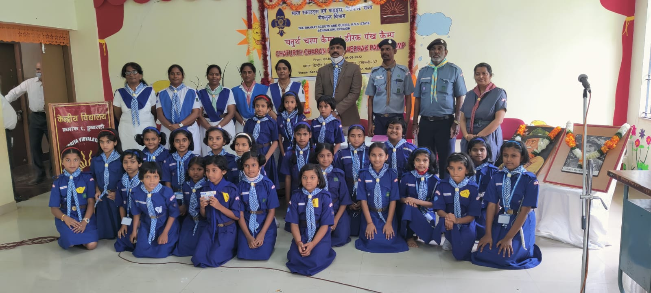

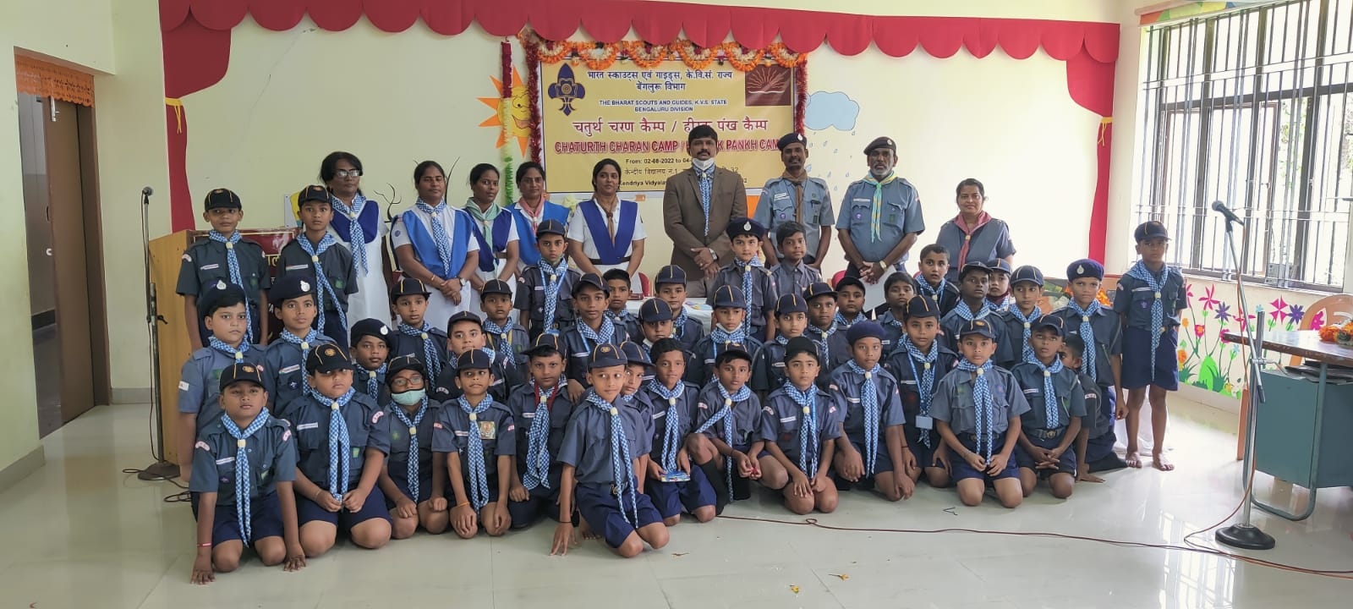

There are various activities that are held during the three-day period. There is a special song, pledge and salute by the cubs and bulbuls. In the end two students of our Vidyalaya has given speech about there experiences in the camp and closing ceremony was held.

