Ek Bharat Shreshtha Bharat
Following Activites are conducted under the banner of Ek Bharat Shreshtha Bharat
- Folk song, folk dance
- Exibition : Art,painting,cuisine,Scriptures
- Demonstration on Uttarakhand cuisine
- Essay writing and Quiz on Fundamental Rights & Duties Premable of Constitution of India
- Self Introduction in Uttarakhand language – Learning 100 Sentences

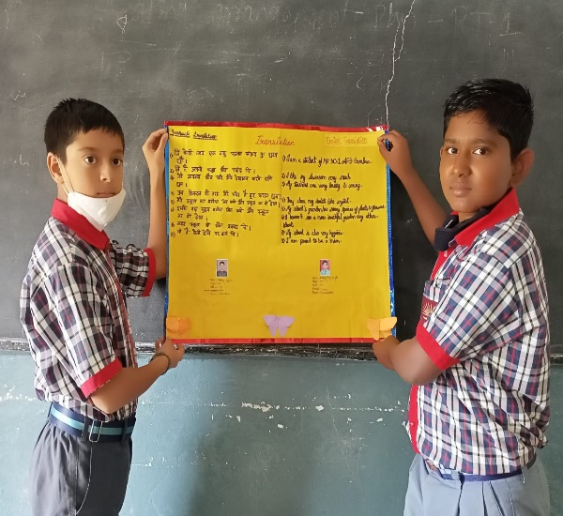
- Learning 100 Sentences
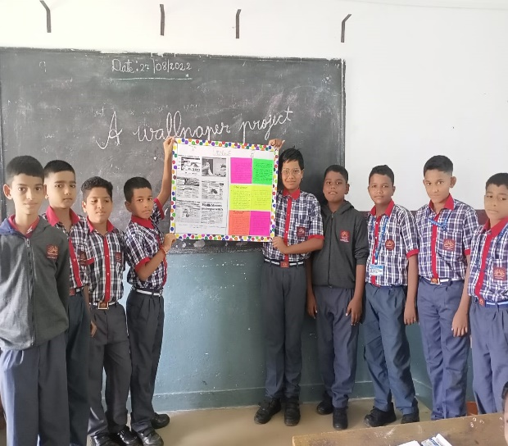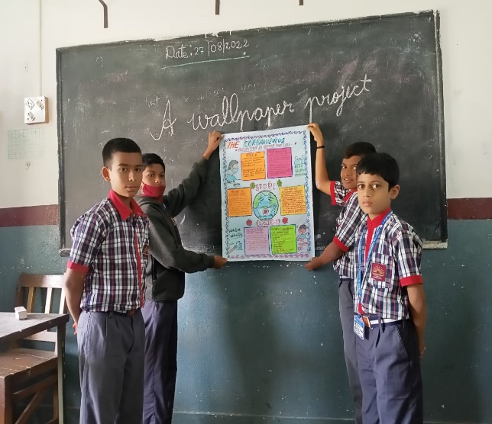
- Wallpaper Project

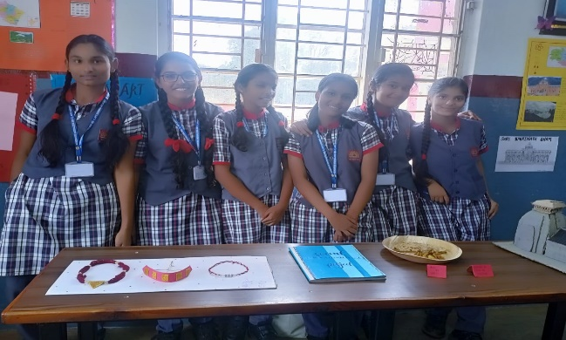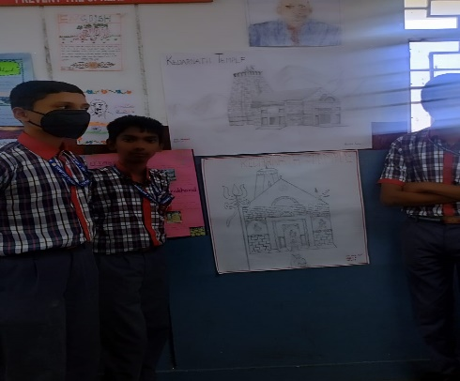
Cuisine and Ornaments of Uttarakhand Sketch of Uttarakhand Temple
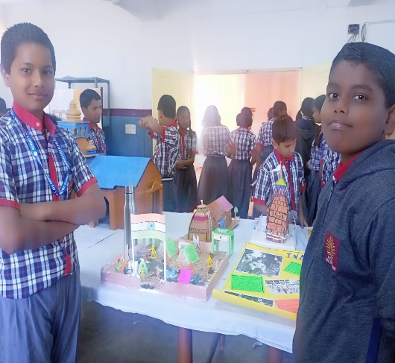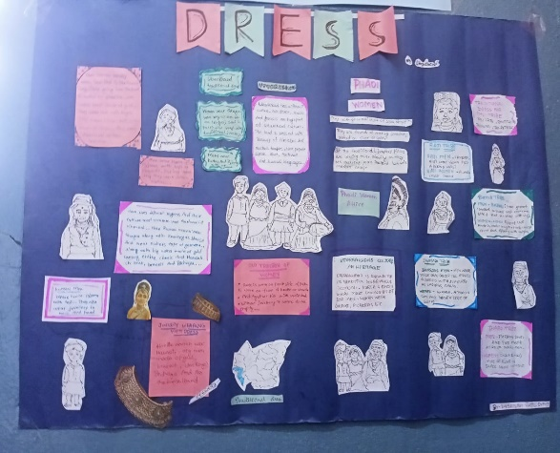
Craft and Models of Uttarakhand
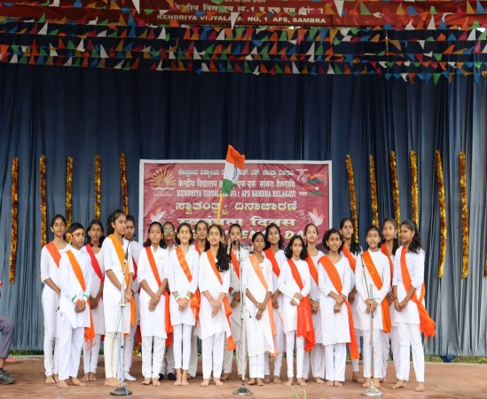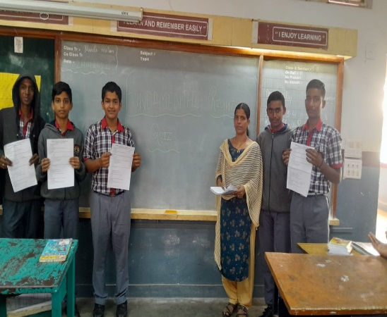
Group Folk Song of Uttarakhand Quiz on Fundamental Rights and Duties

