**ANIMAL MASK**

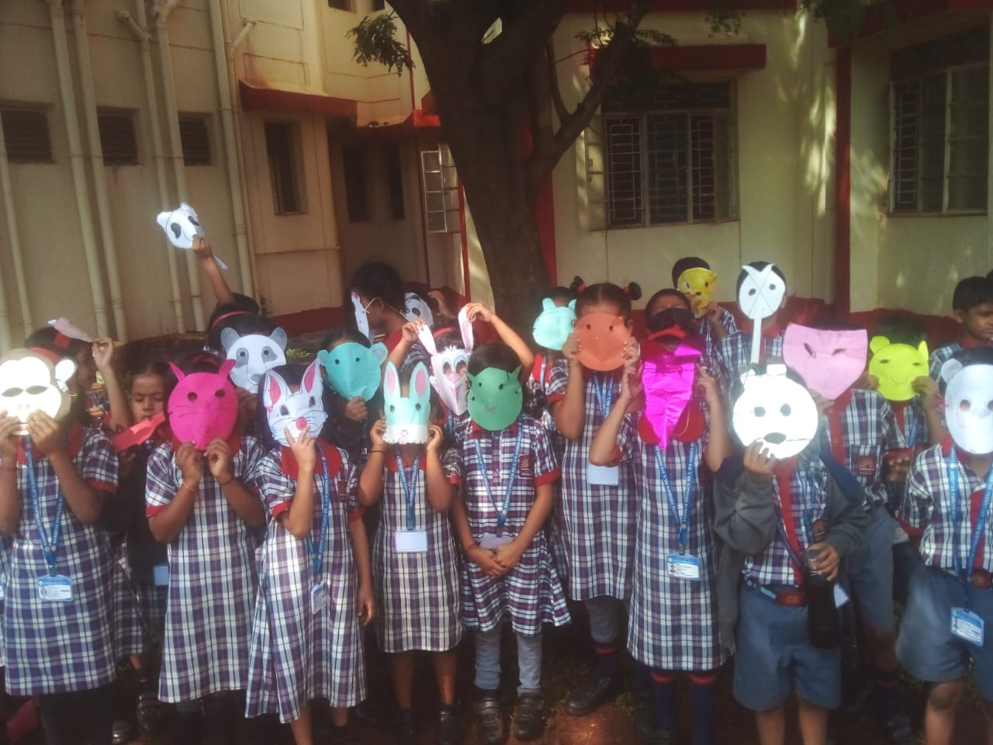

**FLOWER MASK**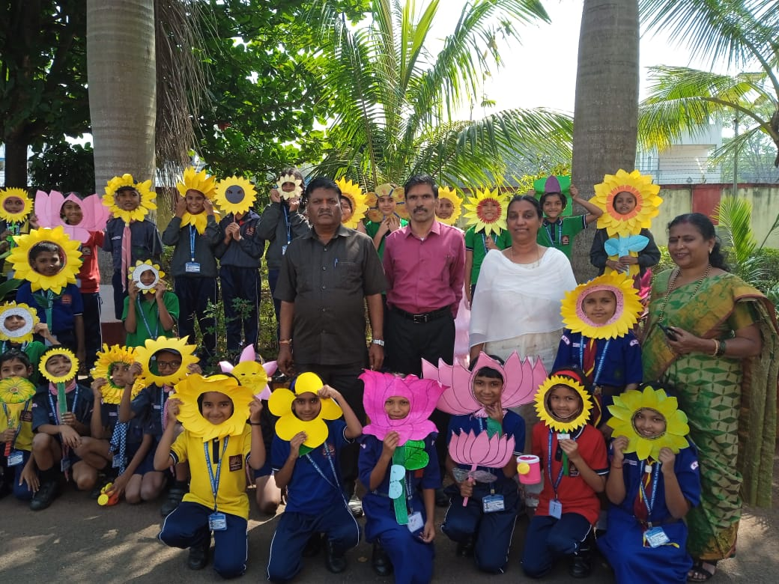

**FINGER PUPPET ACTIVITY**

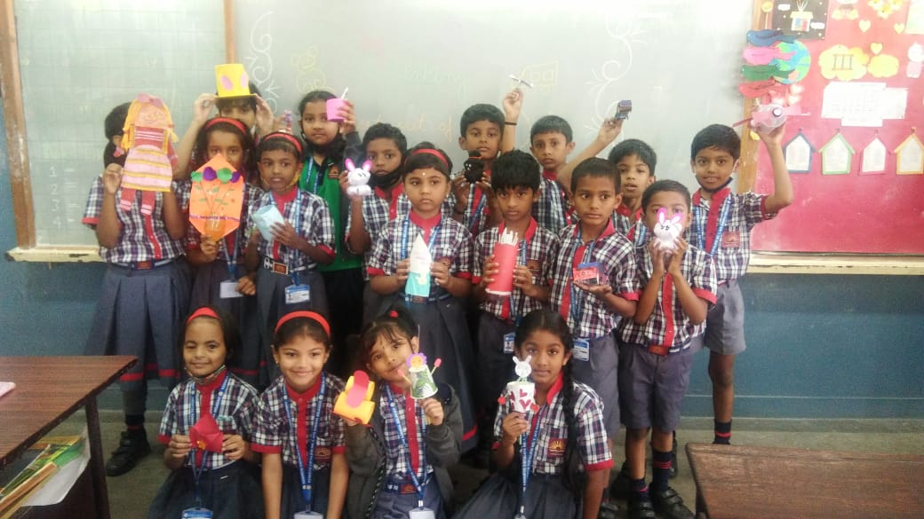

**DIYA DECORATION**

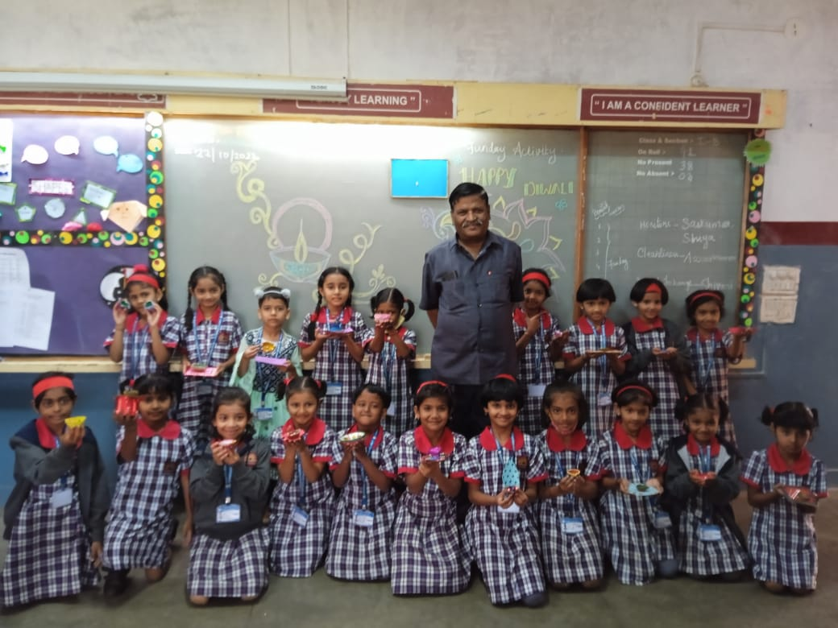

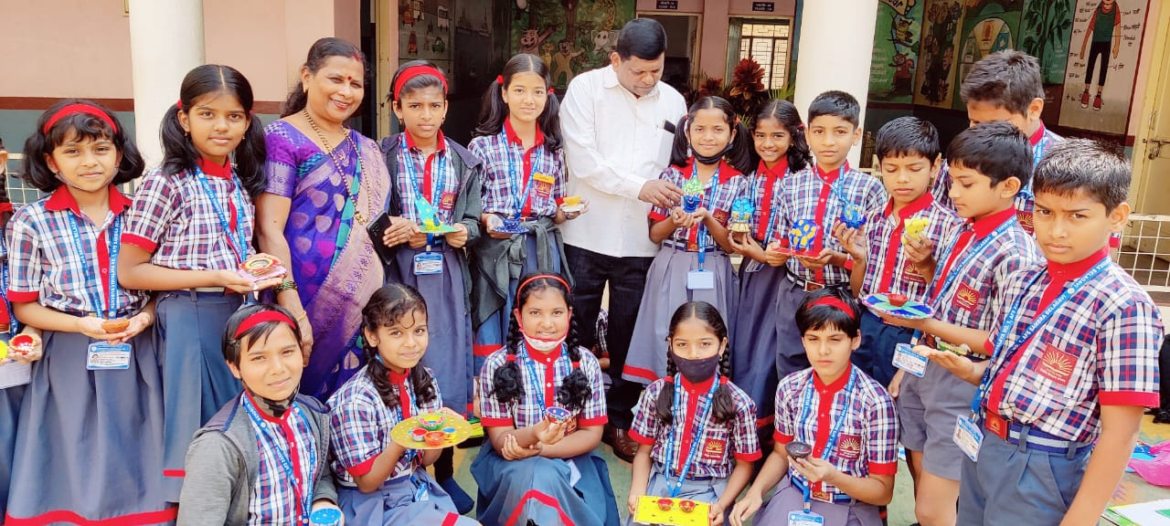

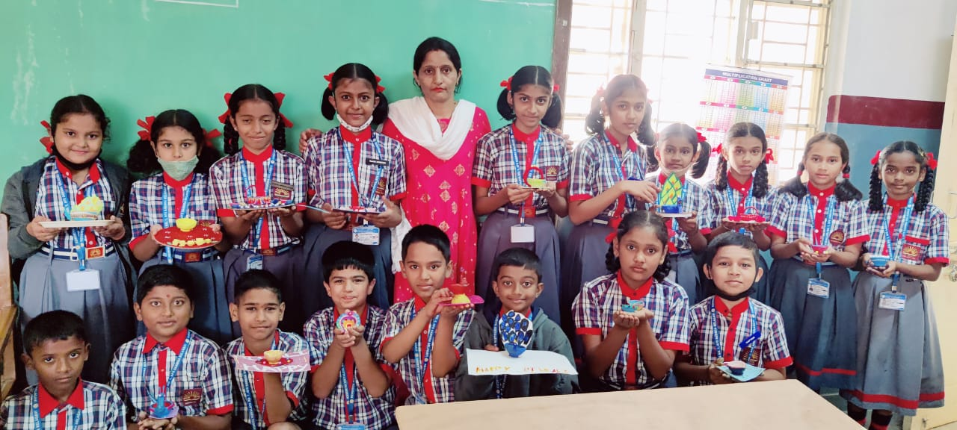

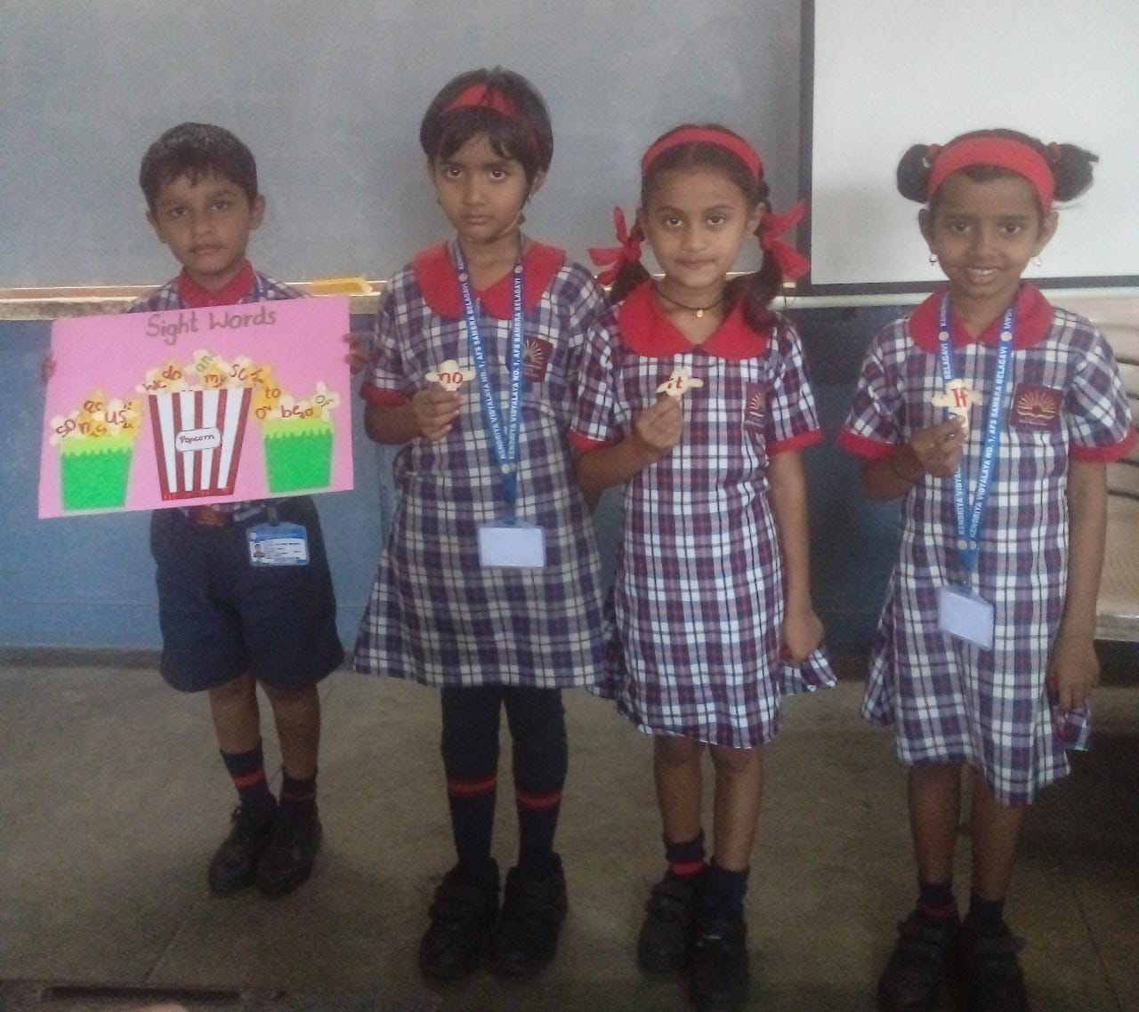**SIGHT WORDS ACTIVITY**

**TREE DECORATION**

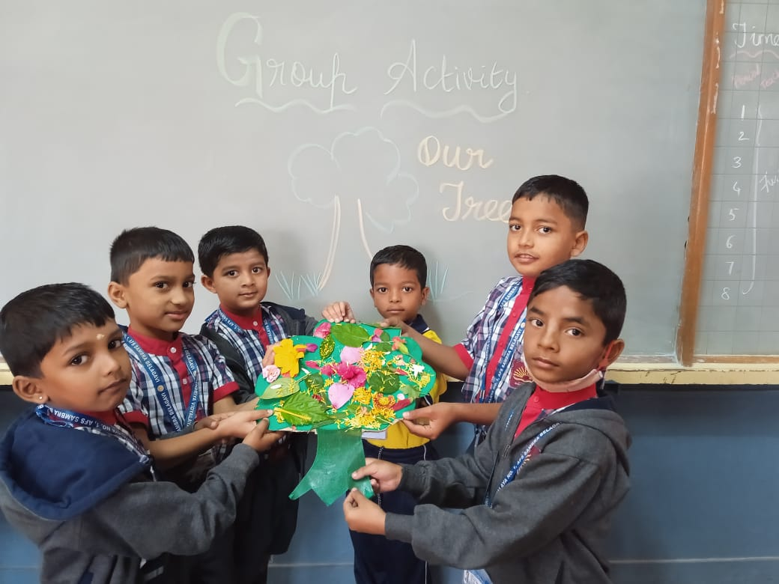

**LEARNING OF SHAPES AND COLOURS**

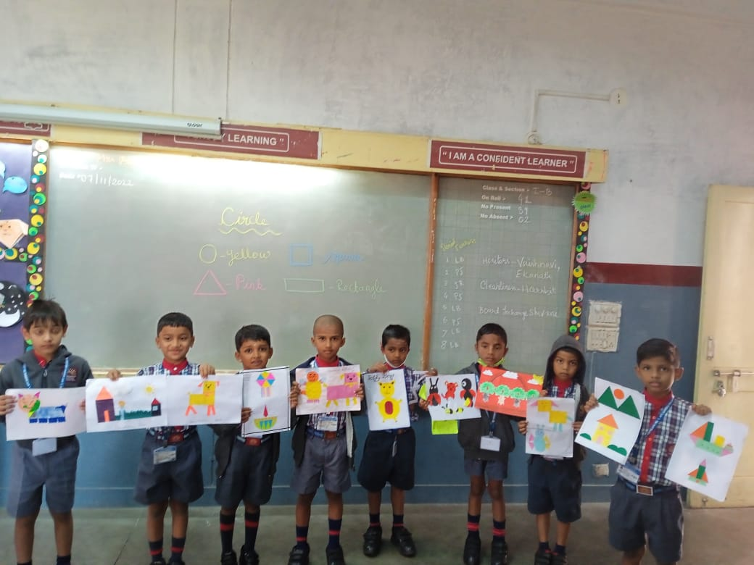

**SHAPES SHUFFLE**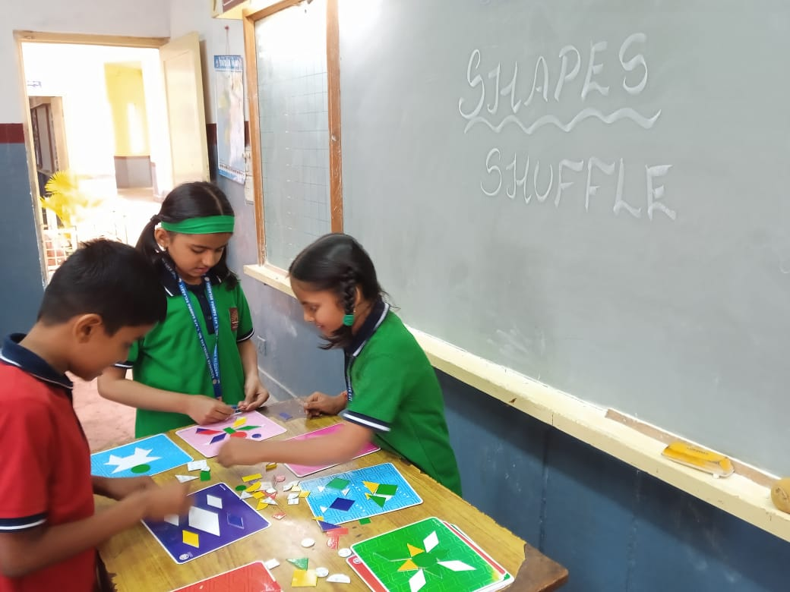

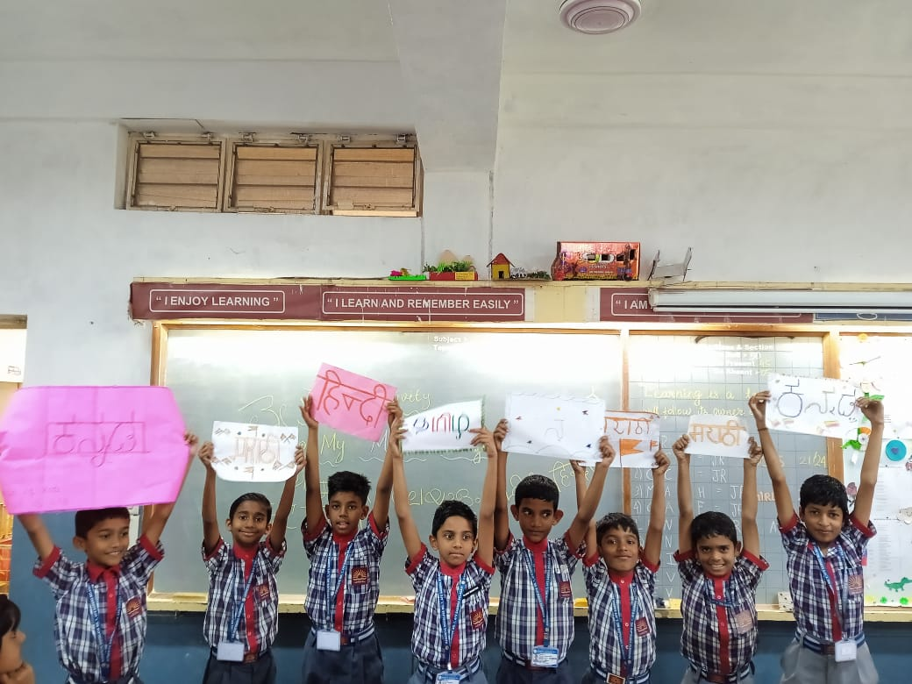**MOTHER TONGUE ACTIVITY**

**BALLOON RACE – FUNDAY ACTIVITY**

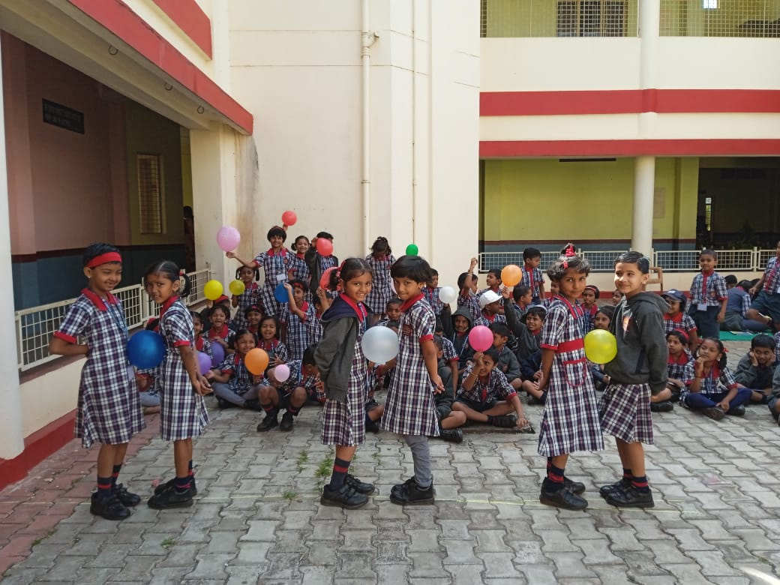

**MULTIPLICATION USING BALLS**

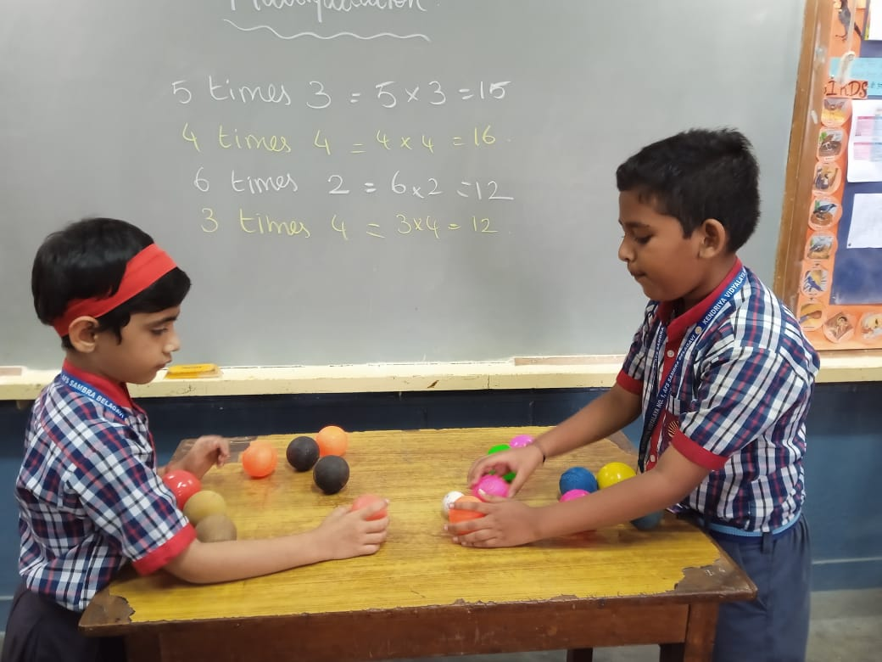

**MEMORY GAME**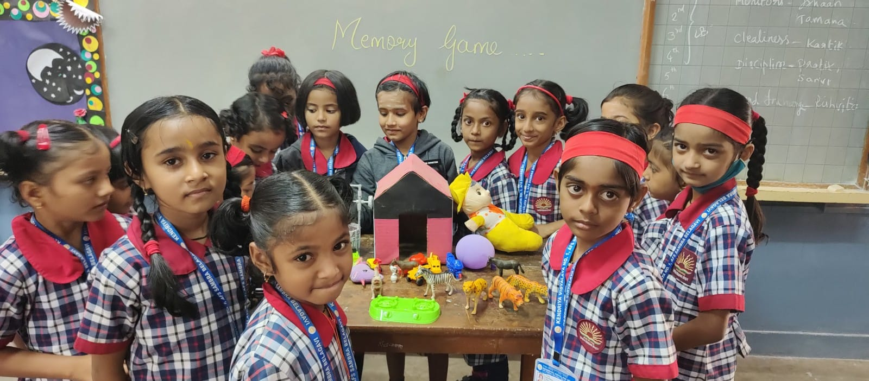

**SMILEY MAKING**

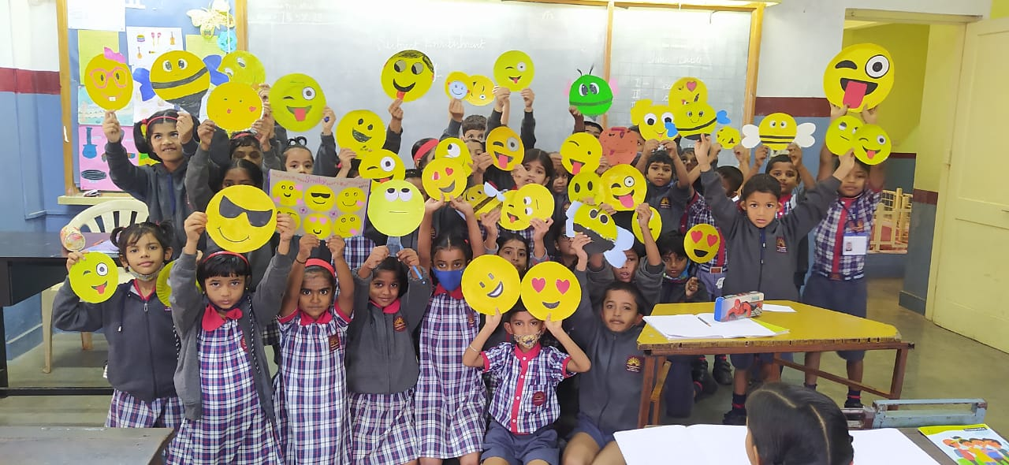

**INDOOR GAMES**

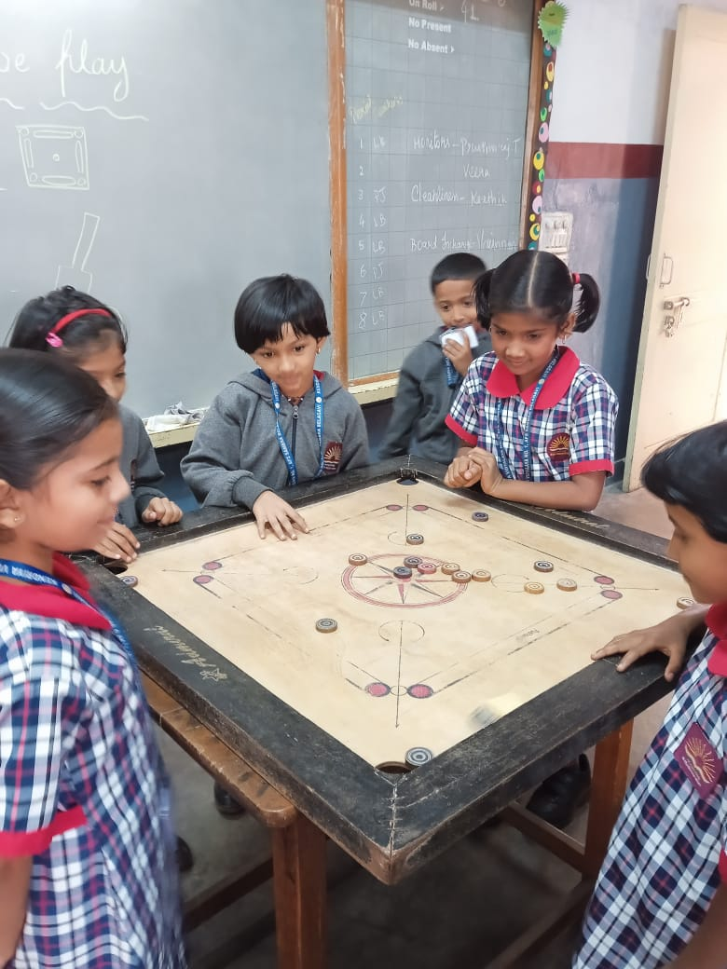

**READING CAMPAIGN**

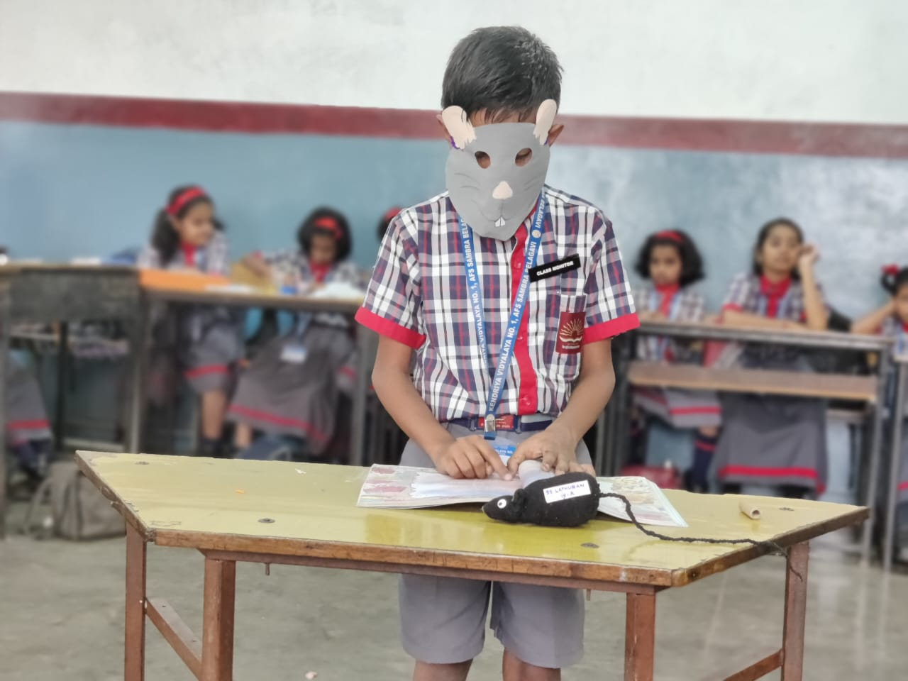

**SELF DIYA MAKING**

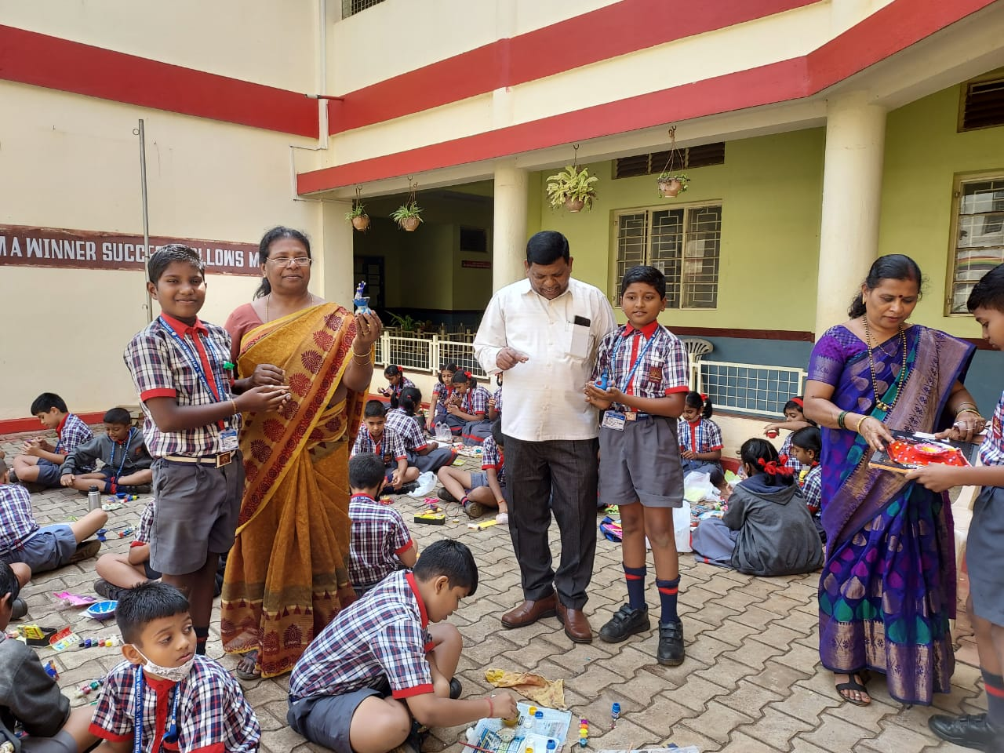

**LEARNING THE MEASUREMENT**

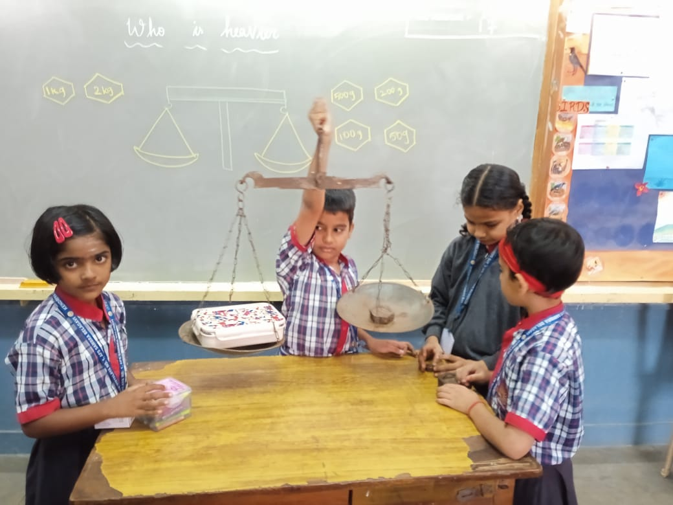

**MAKING TOYS USING CRAFT PAPER**

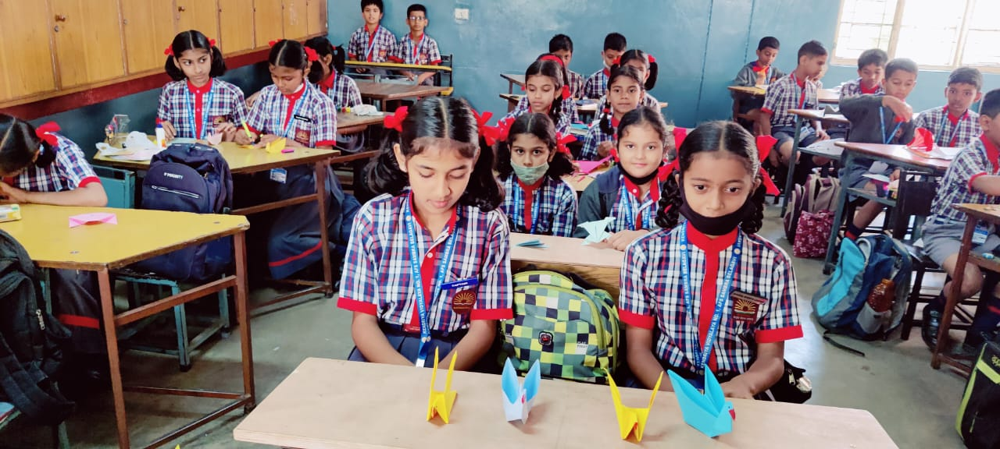

**WARLI ART**

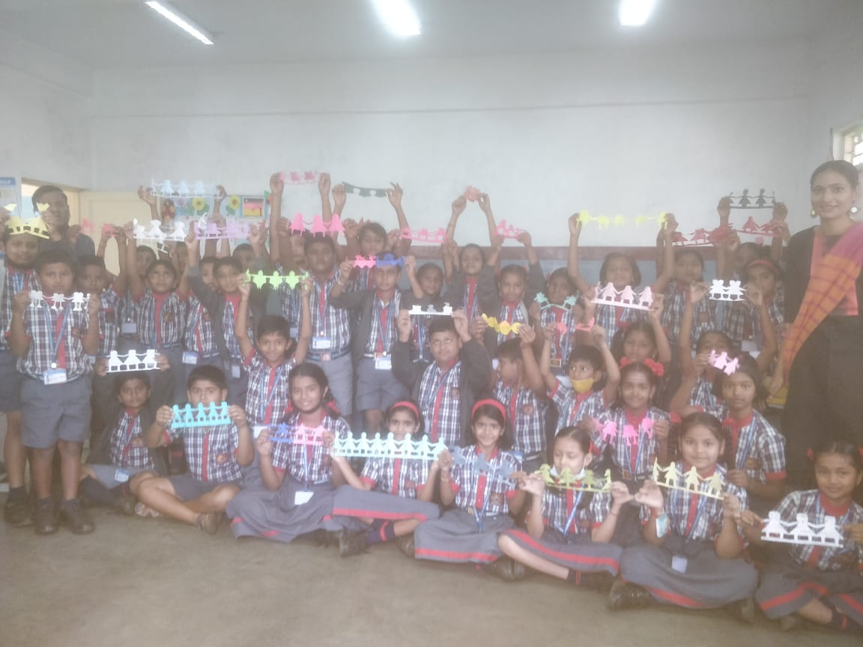

**ENGLISH SKIT**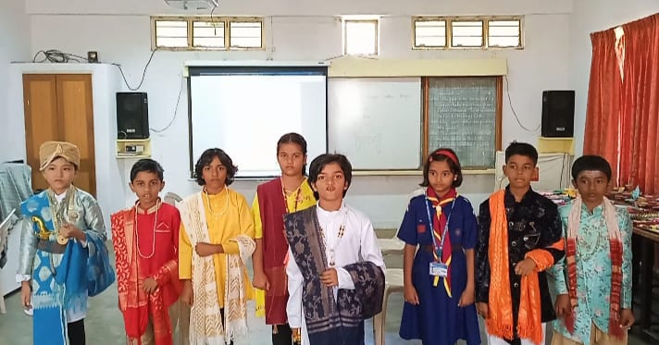

**TOY MAKING – BEST OUT OF WASTE**

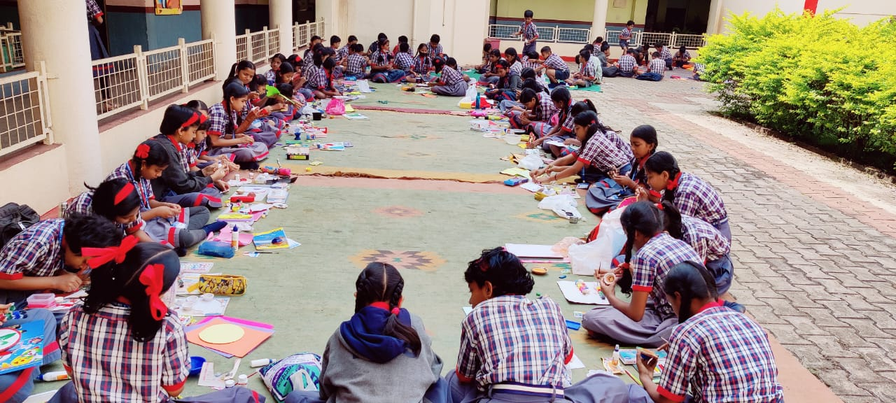

**FUNDAY ACTIVITY - DANCE**

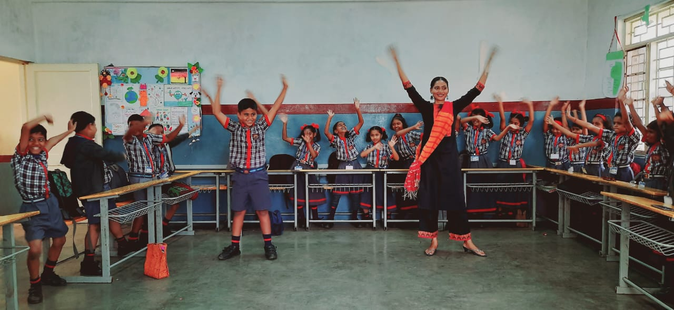

**ACTION SONG** 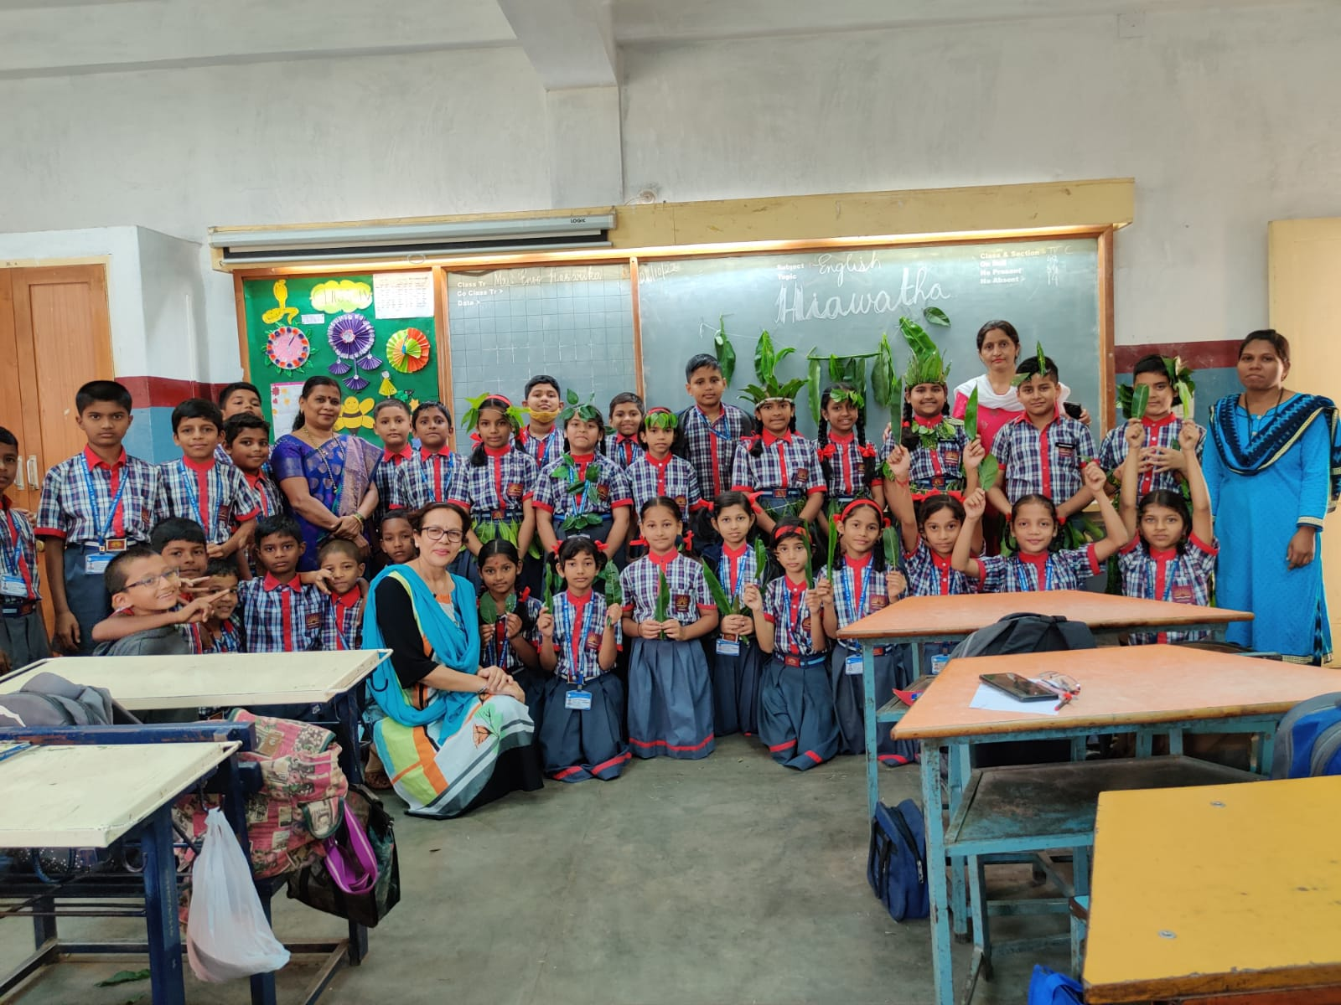

**‘WHAT IS COOKING’ ACTIVITY USING TOYS**

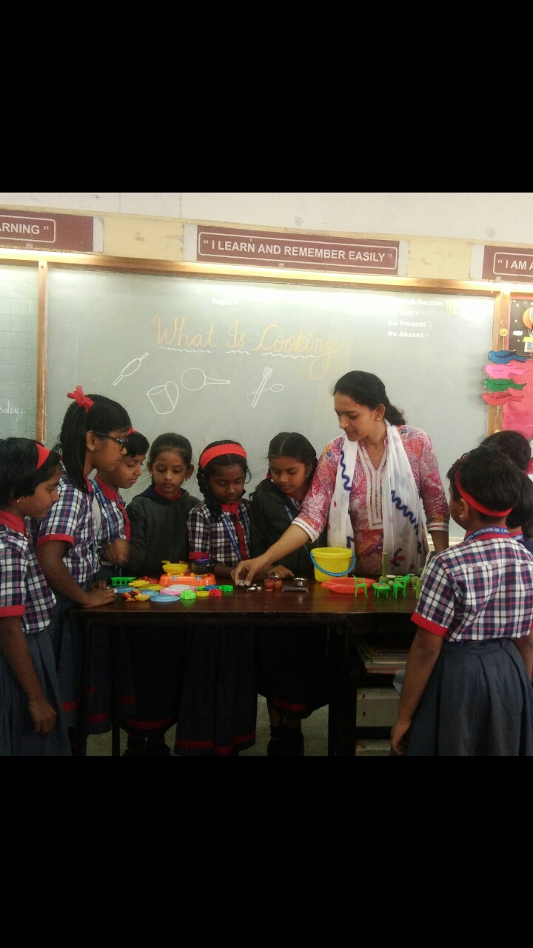

**SONG WITH ACTION AND TOYS**

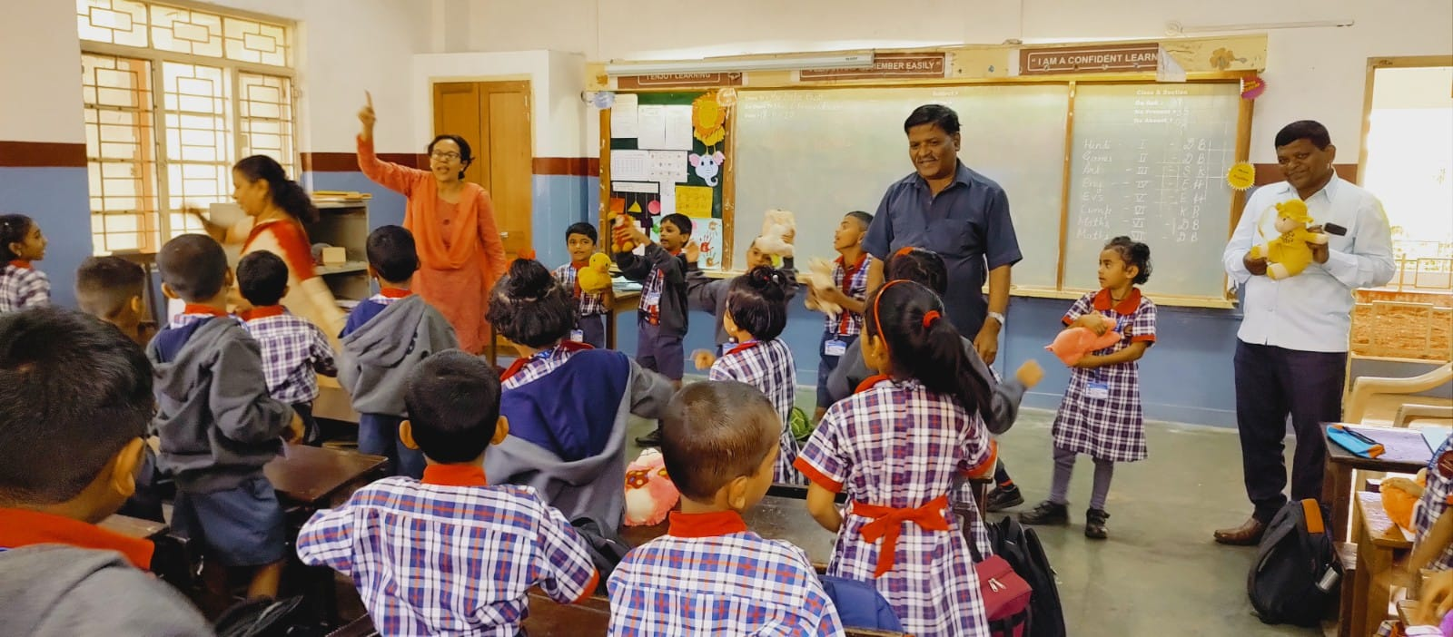

**FUNDAY ACTIVITY - ENGLISH SPEAKING**