CBSE SCHOOL TOPPERS 2018-19
CLASS – XII
SCIENCE STREAM

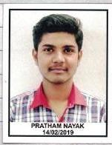
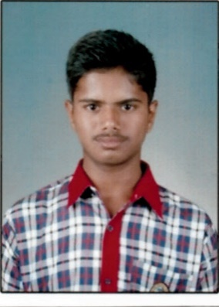
PRATHAM NAYAK TUSHAR AWASTHI REETURAJ DUBEY
96.20% 95.40% 91.80%
COMMERCE STREAM
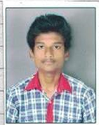 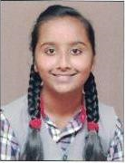
SUMPRIT CHANDAKE HARENDER RITIKA
87.60% 79.04% 73.06%

HUMANITIES STREAM

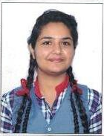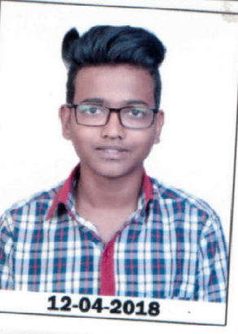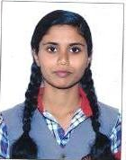
MANSI SUSHMIT BAMANE SHRUTI
72% 72% 66.06%

CBSE SCHOOL TOPPERS
CLASS – X

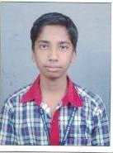
VITTAL V B
95.60%
( Has been awarded certificate of merit by CBSE for his outstanding academic performance and for being among the top 0.1percent of successful candidates. He also scored 100/100 in Social Science.)

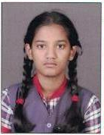
ASTHA KUMARI UTSAV JHA ANCHAL MANDOLKAR
96.60% 95.60% 94.60 %

